**CASE STUDY 3**

1. What is the gender distribution in the organization? Distil to regions and departments

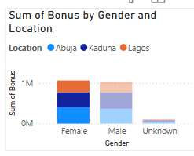

1. Show insights on ratings based on gender

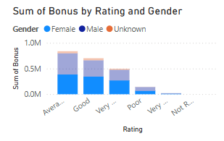

3. Analyse the company’s salary structure. Identify if there is a gender pay gap. If there is, identify the department and regions that should be the focus of management

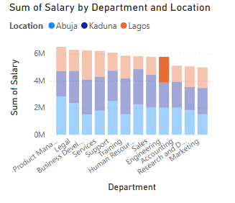

4. A recent regulation was adopted which requires manufacturing companies to pay employees a minimum of $90,000

● Does Palmoria meet this requirement?

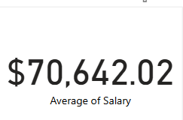

This is the average salary of Palmoria, it does not up the requirement

● Show the pay distribution of employees grouped by a band of $10,000. For example:

● How many employees fall into a band of $10,000 – $20,000, $20,000 – $30,000, etc.?

● Also visualize this by regions

Case Questions

5. Mr Gamma thought to himself that since you were already working on the employee data, you could help out with allocating the annual bonus pay to employees based on the performance rating. He handed you another data set that contains rules for making bonus payments and asked you to:

● Calculate the amount to be paid as a bonus to individual employees

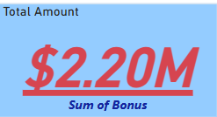

This is the total bonus paid to employees

● Calculate the total amount to be paid to individual employees (salary inclusive of bonus)

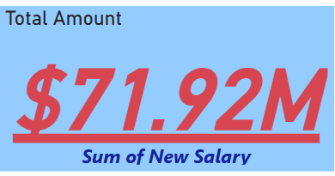

● Total amount to be paid out per region and company-wide

